# Technical Guide for the BMI calculator version 1.0

By Savelij Borovskij

# Content Page

# Development environment

For the development environment I chose Visual Basic .NET programming language. As an environment I used console programming, which is procedural programming.

# Target Platform

The target platform for the BMI Calculator program is Windows operating system.

# User Requirements

The demo program is called BMI Calculator. You are asked to produce a Console Program using VB.NET IDE. The Console program should include a simple menu with the following options: 1. On screen help; 2. Calculate BMI; 3. Exit.

In addition, you may consider:

1. Provide user an option to calculate using either metric or imperial units
2. Adding the following functionality to the menu options: save the result (e.g. the name, age, sex, BMI and date of the calculations); display one’s BMI history.

# Design of the programming solution (screen layout)

Screen 1 is the main screen, which arrived when user first opens my calculator. It has its name at the top, instructions for user and three functions. It also has the section with description of where user’s input will appear.

Screen 1

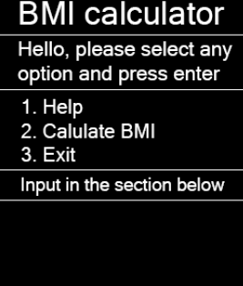

Screen 2 appears when user choose option 2 (calculate BMI) and it asks user to type weight first and then goes to screen 3.

Screen 2

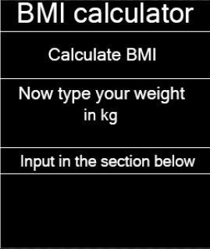

Screen 3 is pretty much like screen 2. The only difference is that now the program asks user’s height. After that he calculates the BMI and shows screen 4.

Screen 3

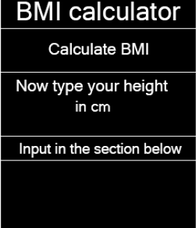

Screen 4 shows user the result and asks to press any button to go back to start (screen 1).

Screen 4

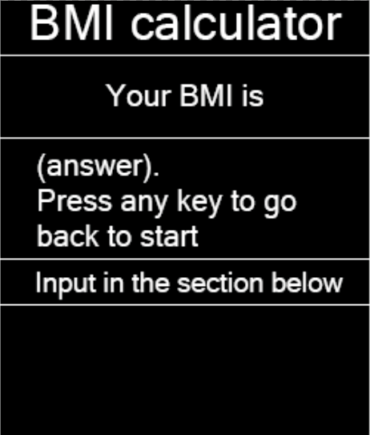

Screen 5 will appear if user select option 1 on screen 1 which is help. It will show help and ask user to type anything to go back to start (screen 1).

Screen 5

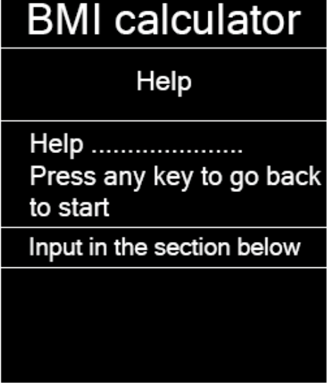

## Working program

Once you run my program a console window will appear with a small design and the name of the program (BMI Calculator), as well as the some comments to help to understand what you need to type and how to navigate in the interface. There will also be 5 different options to choose from.

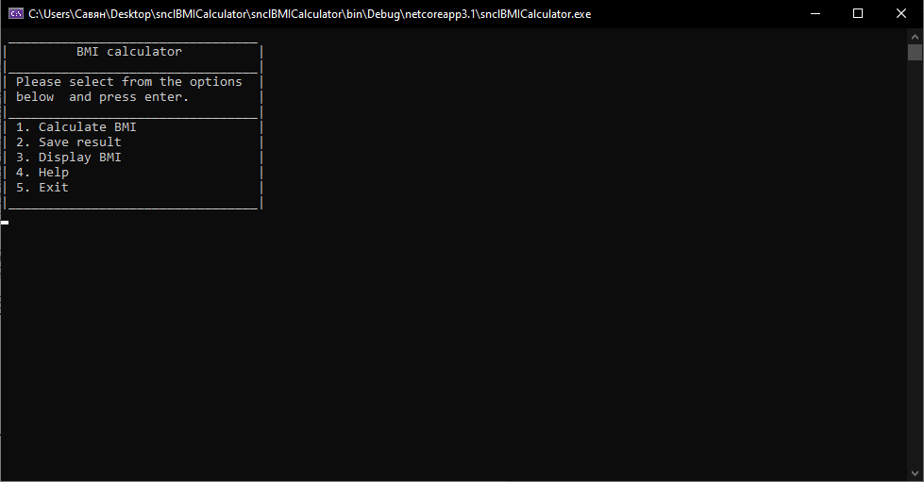

After reading the options, you will need to select one of five and press ‘enter’. The first option is 'Calculate BMI', so I’ll choose it. If you enter the wrong value, an error message will come out, which will inform the user about the error.

(Error message)

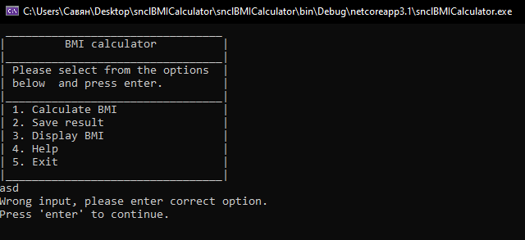

Showing menu in which user can choose a profile to write user’s data on.

(Once entered 1 and pressed enter)

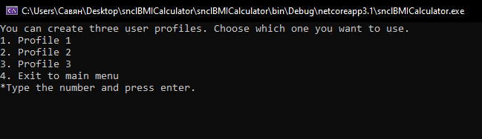

(Choosing ‘Profile 1’. Entering user’s name, height, weight and getting BMI result)

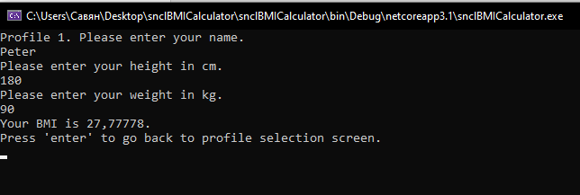

(Choosing ‘Profile 3’. Entering user’s name, height, weight and getting BMI result)

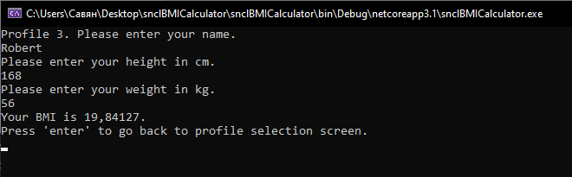

(Clicking option 4, then going back to main menu)

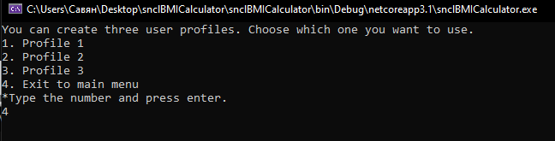

Now I choose option 3 to see if my data was saved.

(Getting all the information and also some guidance on what I can do after.)

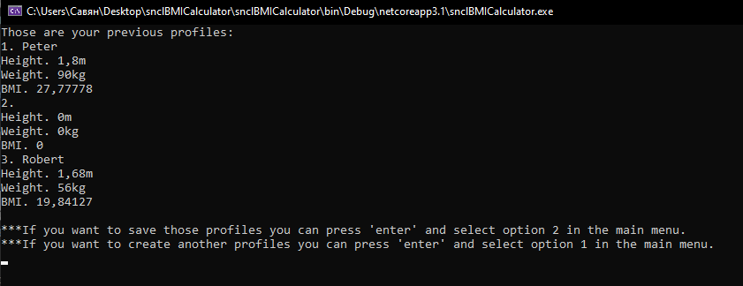

Now I want to check option 4, which is ‘help’.

(Help menu)

???SCREENSHOT???

Currently I want to save all my data to a txt file, so I choose option 2.

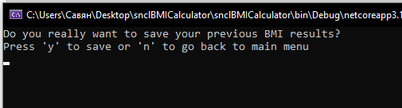

Confirming it, by typing y.

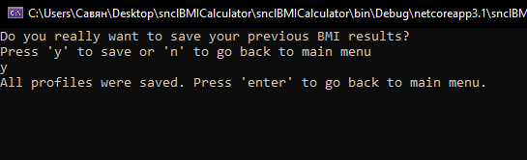

And checking if all data is saved.

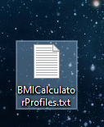 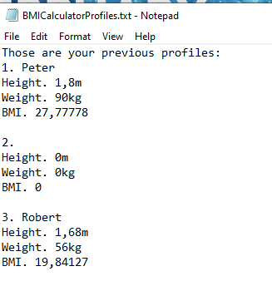

So for now I just need to exit the program so I go back to main screen end select option 5.

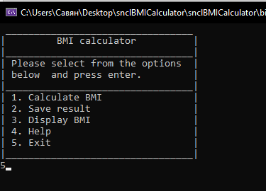

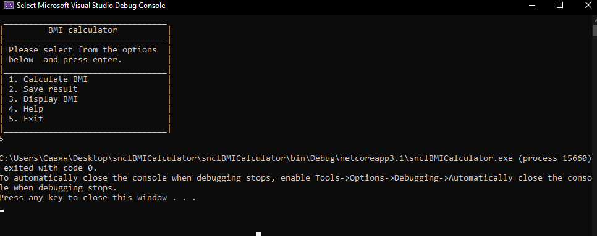

And close the program.

# Code

Imports System.IO 'pre-defined library for file i/o operations.

''' <summary>

''' I am implementing a standart BMI calculator, which consists of 5 main options(1.calculate BMI, 2.save result, 3.display BMI, 4.help, 5.exit).

''' The program calculates BMI by using cm and kg units. The program will create a .txt file to save data, that user enter. User can have 3 different profiles.

''' </summary>

''' Author: SB

''' Date created: 6/02/2020

''' Date modified: 11/02/2020

Module mdlBMICalculator

Dim UserOption As String 'declarating global variable as a option for user to choose

Dim UserInfo(3) As UserData 'declarating global variable as a 'UserData' structure and setting an array of 4 variables.

Sub Main()

Call MainMenu() 'Showing main menu

End Sub

Sub MainMenu() 'creating a new sub to divide code into separate sections

Do 'looping the menu

Console.Clear() 'to clean everything that was before the main menu

Console.WriteLine(" _________________________________")

Console.WriteLine("| BMI calculator |")

Console.WriteLine("|_________________________________|")

Console.WriteLine("| Please select from the options |")

Console.WriteLine("| below and press enter. |") 'program design

Console.WriteLine("|_________________________________|")

Console.WriteLine("| 1. Calculate BMI |")

Console.WriteLine("| 2. Save result |")

Console.WriteLine("| 3. Display BMI |")

Console.WriteLine("| 4. Help |")

Console.WriteLine("| 5. Exit |")

Console.WriteLine("|_________________________________|")

UserOption = Console.ReadLine() 'making user's input equal to 'UserOption' variable

Call UserInput() 'displaying UserInput sub

Loop

End Sub 'closing sub

Sub UserInput()

Select Case UserOption 'allows you to assign a specific input to perform certain tasks

'displaying different menu options by calling subs and clearing everything that was displayed before

Case "1"

Console.Clear()

Call BMICalculation()

Case "2"

Console.Clear()

Call SaveResult()

Case "3"

Console.Clear()

Call DisplayBMI()

Case "4"

Console.Clear()

Call HelpMenu()

Case "5"

Call ExitMenu()

Case Else

Console.WriteLine("Wrong input, please enter correct option.") 'error message in case user choose wrong option

Console.WriteLine("Press 'enter' to continue.")

Console.ReadLine()

Console.Clear()

End Select

Console.Clear()

End Sub

Sub BMICalculation()

Do

Console.WriteLine("You can create three user profiles. Choose which one you want to use.")

Console.WriteLine("1. Profile 1")

Console.WriteLine("2. Profile 2") 'design

Console.WriteLine("3. Profile 3")

Console.WriteLine("4. Exit to main menu")

Console.WriteLine("*Type the number and press enter.") 'tip for user

UserOption = Console.ReadLine()

Select Case UserOption

Case "1"

Console.Clear()

Console.WriteLine("Profile 1. Please enter your name.") 'tip for user

UserInfo(1).Name = Console.ReadLine 'making user's input equal to 'UserInfo.Name' variable in structure

Console.WriteLine("Please enter your height in cm.")

UserInfo(1).Height = Console.ReadLine 'making user's input equal to 'UserInfo.Height' variable in structure

Console.WriteLine("Please enter your weight in kg.")

UserInfo(1).Weight = Console.ReadLine 'making user's input equal to 'UserInfo.Weight' variable in structure

UserInfo(1).Height = UserInfo(1).Height / 100 'convering cm to m for the formula

UserInfo(1).Result = UserInfo(1).Weight / (UserInfo(1).Height * UserInfo(1).Height) 'formula for BMI calculation

Console.WriteLine("Your BMI is " & UserInfo(1).Result & ".") 'shows user the answer

Console.WriteLine("Press 'enter' to go back to profile selection screen.") 'tip for user

Console.ReadLine()

Console.Clear()

Case "2"

Console.Clear()

Console.WriteLine("Profile 2. Please enter your name.") 'tip for user

UserInfo(2).Name = Console.ReadLine 'making user's input equal to 'UserInfo.Name' variable in structure

Console.WriteLine("Please enter your height in cm.")

UserInfo(2).Height = Console.ReadLine 'making user's input equal to 'UserInfo.Height' variable in structure

Console.WriteLine("Please enter your weight in kg.")

UserInfo(2).Weight = Console.ReadLine 'making user's input equal to 'UserInfo.Weight' variable in structure

UserInfo(2).Height = UserInfo(2).Height / 100 'convering cm to m for the formula

UserInfo(2).Result = UserInfo(2).Weight / (UserInfo(2).Height * UserInfo(2).Height) 'formula for BMI calculation

Console.WriteLine("Your BMI is " & UserInfo(2).Result & ".") 'shows user the answer

Console.WriteLine("Press 'enter' to go back to profile selection screen.") 'tip for user

Console.ReadLine()

Console.Clear()

Case "3"

Console.Clear()

Console.WriteLine("Profile 3. Please enter your name.") 'tip for user

UserInfo(3).Name = Console.ReadLine 'making user's input equal to 'UserInfo.Name' variable in structure

Console.WriteLine("Please enter your height in cm.")

UserInfo(3).Height = Console.ReadLine 'making user's input equal to 'UserInfo.Height' variable in structure

Console.WriteLine("Please enter your weight in kg.")

UserInfo(3).Weight = Console.ReadLine 'making user's input equal to 'UserInfo.Weight' variable in structure

UserInfo(3).Height = UserInfo(3).Height / 100 'convering cm to m for the formula

UserInfo(3).Result = UserInfo(3).Weight / (UserInfo(3).Height * UserInfo(3).Height) 'formula for BMI calculation

Console.WriteLine("Your BMI is " & UserInfo(3).Result & ".") 'shows user the answer

Console.WriteLine("Press 'enter' to go back to profile selection screen.") 'tip for user

Console.ReadLine()

Console.Clear()

Case "4"

Call MainMenu()

Case Else

Console.WriteLine("Wrong input, please enter correct option.") 'error message in case user choose wrong option

Console.WriteLine("Press 'enter' to continue.")

Console.ReadLine()

Console.Clear()

End Select

Loop

Console.Clear()

Console.WriteLine("You have created three user's profiles.")

Console.WriteLine("Press 'enter' to go back to main menu.") 'tip for user

Console.ReadLine()

End Sub

Sub SaveResult()

Dim SW As New StreamWriter("\\mcfs01\StudentHome\20014502\IT\BMICalculatorProfiles.txt") 'declaraiting SW as a streamwriter for the .txt file to which data will be recorded

Dim i As Integer 'declaraiting variable 'i'(local variable)

Do 'starting a loop

Console.WriteLine("Do you really want to save your previous BMI results?") 'tip for user

Console.WriteLine("Press 'y' to save or 'n' to go back to main menu")

UserOption = Console.ReadLine() 'making 'UserOption' variable equal to user's input

Select Case UserOption 'using a control structure to the user could choose the appropriate option

Case "y" 'if user type 'y' that option will happend

SW.WriteLine("Those are your previous profiles:")

For i = 1 To 3 'creating a loop which ends when all three variables 'i' are scrolled

'displaying user's profiles in order

SW.WriteLine(i & ". " & UserInfo(i).Name)

SW.WriteLine("Height. " & UserInfo(i).Height & "m")

SW.WriteLine("Weight. " & UserInfo(i).Weight & "kg")

SW.WriteLine("BMI. " & UserInfo(i).Result)

SW.WriteLine("")

Next 'ending loop, so that once it reaches 3, code will continue to execute

SW.Close() 'closing streamwriter, so the data can now be read

Console.WriteLine("All profiles were saved. Press 'enter' to go back to main menu.") 'tip for user

Console.ReadLine()

Call MainMenu()

Case "n" 'if user type 'n' that option will happend

Call MainMenu()

Case Else 'if there will be any other input not listed above then this will appear

Console.WriteLine("Wrong input, please enter correct option.")

Console.WriteLine("Press 'enter' to continue.") 'tip for user

Console.ReadLine()

Console.Clear()

End Select 'closing control structure

Loop 'closing the loop

End Sub

Sub DisplayBMI()

Dim i As Integer 'declaraiting variable 'i'(local variable)

Console.WriteLine("Those are your previous profiles:")

For i = 1 To 3 'creating a loop to list all user's data

Console.WriteLine(i & ". " & UserInfo(i).Name)

Console.WriteLine("Height. " & UserInfo(i).Height & "m") 'displaying user's profiles data

Console.WriteLine("Weight. " & UserInfo(i).Weight & "kg")

Console.WriteLine("BMI. " & UserInfo(i).Result)

Next 'closing the loop

Console.WriteLine("") 'making a gap between text

Console.WriteLine("***If you want to save those profiles you can press 'enter' and select option 2 in the main menu.") 'some advices for user

Console.WriteLine("***If you want to create another profiles you can press 'enter' and select option 1 in the main menu.")

Console.ReadLine()

End Sub

Sub HelpMenu()

Do

Console.WriteLine("What help do you need?") 'tip for user

Console.WriteLine("1. How to use a program?")

Console.WriteLine("2. What do the options do?") 'design for options that user can choose

Console.WriteLine("3. Tips and advices.")

Console.WriteLine("4. Program description.")

Console.WriteLine("5. What is BMI?")

Console.WriteLine("6. Exit to the main menu")

UserOption = Console.ReadLine() 'making 'UserOption' variable equal to user's input

Console.Clear()

Select Case UserOption 'using a control structure to the user could choose the appropriate option

Case "1"

Console.WriteLine("To navigate in program you should select appropriate options and press enter. ")

Console.WriteLine("Press 'enter' to go back to Help Menu.")

Console.ReadLine()

Console.Clear()

Case "2"

Console.WriteLine("Option 1 - Calculates user's BMI by asking Name for the profile,")

Console.WriteLine("height and weight. Than user recieve its BMI, that is saved to a")

Console.WriteLine("specific profile.")

Console.WriteLine("______________________________________")

Console.WriteLine("Option 2 - Saves all user's profiles to a .txt file with all user's")

Console.WriteLine("data, including name, height, weight and BMI.")

Console.WriteLine("______________________________________")

Console.WriteLine("Option 3 - Displays all the profiles, that were created during BMI calculations")

Console.WriteLine("______________________________________")

Console.WriteLine("Option 4 - Help menu, with guidance and suggestions for the user.")

Console.WriteLine("______________________________________")

Console.WriteLine("Option 5 - Option to quit the program")

Console.WriteLine("______________________________________")

Console.WriteLine("Press 'enter' to go back to Help Menu.")

Console.ReadLine()

Console.Clear()

Case "3"

Console.WriteLine("1. If you choose an option you should type only values, that are required. Otherwise you'll recieve an error or crash a program.")

Console.WriteLine("2. You should input correct weight and height to recieve a proper BMI and make sure you write them in the correct unit.")

Console.WriteLine("3. Read carefully all the tip messages, that can help you understand what to do further in the program.")

Console.WriteLine("______________________________________")

Console.WriteLine("Press 'enter' to go back to Help Menu.")

Console.ReadLine()

Console.Clear()

Case "4"

Console.WriteLine("It is a standart BMI calculator, which consists of 5 main options(1.calculate BMI, 2.save result, 3.display BMI, 4.help, 5.exit).")

Console.WriteLine("The program calculates BMI by using cm and kg units. User can have 3 different profiles.")

Console.WriteLine("______________________________________")

Console.WriteLine("Press 'enter' to go back to Help Menu.")

Console.ReadLine()

Console.Clear()

Case "5"

Console.WriteLine("The body mass index (BMI) is a measure that uses your height and weight to work out if your weight is healthy.")

Console.WriteLine("For most adults, BMI range is:")

Console.WriteLine("1. Below 18.5 - you're in the underweight range")

Console.WriteLine("2. Between 18.5 and 24.9 - you're in the healthy weight range")

Console.WriteLine("3. Between 25 and 29.9 - you're in the overweight range")

Console.WriteLine("4. Between 30 and 39.9 – you're in the obese range")

Console.WriteLine("______________________________________")

Console.WriteLine("Press 'enter' to go back to Help Menu.")

Console.ReadLine()

Console.Clear()

Case "6"

Call MainMenu()

Case Else

Console.WriteLine("Wrong input, please enter correct option.")

Console.WriteLine("Press 'enter' to continue.") 'error message

Console.ReadLine()

Console.Clear()

End Select

Loop

End Sub

Sub ExitMenu()

End 'command that will close the program

End Sub

Structure UserData 'making a structure

Dim Height As Single

Dim Weight As Single 'declarating variables in structure

Dim Result As Single

Dim Name As String

End Structure 'closing a structure

End Module

# Test plan

|  |  |  |  |  |
| --- | --- | --- | --- | --- |
| No. | What tested (Test Item) | Test data | Expected outcome | **Test description** |
| 1 | Weight(kg) | 90 | Accept | Test if the program accepts the correct input. |
| 2 | Weight(kg) | -1 | Not accept | Test if the program does not accept the incorrect input. |
| 3 | Weight(kg) | 300 | Not accept | Test if the program does not accept the incorrect input. |
| 4 | Weight(kg) | abc | Not accept | Test if the program does not accept the incorrect input. |
| 5 | Weight | ‘’ | Not accept | Test if the program does not accept the incorrect input.(none input) |
| 6 | Height(cm) | 180 | Accept | Test if the program accepts the correct input. |
| 7 | Height(cm) | 400 | Not accept | Test if the program does not accept the incorrect input. |
| 8 | Height(cm) | -1 | Not accept | Test if the program does not accept the incorrect input. |
| 9 | Height(cm) | abc | Not accept | Test if the program does not accept the incorrect input. |
| 10 | Name | ‘’ | Not accept | Test if the program does not accept the incorrect input. (none input) |
| 11 | Name | Sava | Accept | Test if the program accepts the correct input. |
| 12 | Name | 123 | Not accept | Test if the program does not accept the incorrect input.(numbers) |
| 13 | Name | ‘’ | Not accept | Test if the program does not accept the incorrect input. (none input) |
| 14 | Name | Sava123 | Not accept | Test if the program does not accept the incorrect input.(numbers in name) |

## BMI Calculator test log

|  |  |  |  |  |  |
| --- | --- | --- | --- | --- | --- |
| No. | What tested (Test Item) | Test data | Expected outcome | Actual outcome | Note |
| 1 | Weight(kg) | 90 | Accept | Accept | Passed |
| 2 | Weight(kg) | -1 | Not accept | Accept | Not passed |
| 3 | Weight(kg) | 300 | Not accept | Accept | Not passed |
| 4 | Weight(kg) | abc | Not accept | Accept | Not passed |
| 5 | Weight(kg) | ‘’ | Not accept | Accept | Not passed |
| 6 | Height(cm) | 180 | Accept | Accept | Passed |
| 7 | Height(cm) | 400 | Not accept | Accept | Not passed |
| 8 | Height(cm) | -1 | Not accept | Accept | Not passed |
| 9 | Height(cm) | abc | Not accept | Accept | Not passed |
| 10 | Height(cm) | ‘’ | Not accept | Accept | Not passed |
| 11 | Name | Sava | Accept | Accept | Passed |
| 12 | Name | 123 | Not accept | Accept | Not passed |
| 13 | Name | ‘’ | Not accept | Accept | Not passed |
| 14 | Name | Sava123 | Not accept | Accept | Not passed |

## Error Testing Log

|  |  |  |  |
| --- | --- | --- | --- |
| Error Testing Log | | | |
| Project: BMICalculator | Reference: | | Priority: medium |
| Tester name: Savelij Borovskij | Date: 2/12/2020 | | Test case: 2 |
| Expected outcome:  It is expected that the program will not accept a number below zero and will also show the error 'Height is too small, please enter the correct value'. | | | |
| Actual result:  The program accepted the number and calculated BMI anyway. | | | |
| Cause of problem:  The problem was caused by the lack of necessary lines of code and some variables. In order to solve the problem you need to add the IsNumeric command and create a variable for checking if value is a number. | | | |
| Developer name: Savelij Borovskij | | Date fixed: 2/12/2020 | |

|  |  |  |  |
| --- | --- | --- | --- |
| Error Testing Log | | | |
| Project: BMICalculator | Reference: | | Priority: medium |
| Tester name: Savelij Borovskij | Date: 2/12/2020 | | Test case:13 |
| Expected outcome:  The program will not accept a name without any typing and will show an error message that says ‘No input found, please enter your name.’ | | | |
| Actual result:  The program accepted the name, even though it does not have any input. | | | |
| Cause of problem:  The problem was caused by the fact that there is no line in the code that would prohibit leaving the variable 'name' empty. | | | |
| Developer name: Savelij Borovskij | | Date fixed: 2/12/2020 | |

|  |  |  |  |  |  |
| --- | --- | --- | --- | --- | --- |
| Error Testing Log | | | | | |
| Project: BMICalculator | | Reference: | | | Priority: medium |
| Tester name: Savelij Borovskij | Date: 2/12/2020 | | | Test case:4 | |
| Expected outcome:  Gives an error – ‘Incorrect weight, please enter the correct value’, because characters were entered, not numbers. | | | | | |
| Actual result:  The program crashes. | | | | | |
| Cause of problem:  The problem is that there is no line in the code that allows you to limit the input only to numbers, as well as the error itself. Therefore, a date of type 'single' cannot accept characters and crashes the program. | | | | | |
| Developer name: Savelij Borovskij | | | Date fixed: 2/12/2020 | | |

# Maintenance

To service my program, I will need to conduct tests and debugs every month. To do this, feedback from users will be collected and errors will be checked and resolved. Also in the future, it is planned to improve the graphic design by supplementing the interface and adding various frames, lines, etc.